HackerRank Program 1
Link :- https://www.hackerrank.com/challenges/solve-me-first/problem
Successful Submission
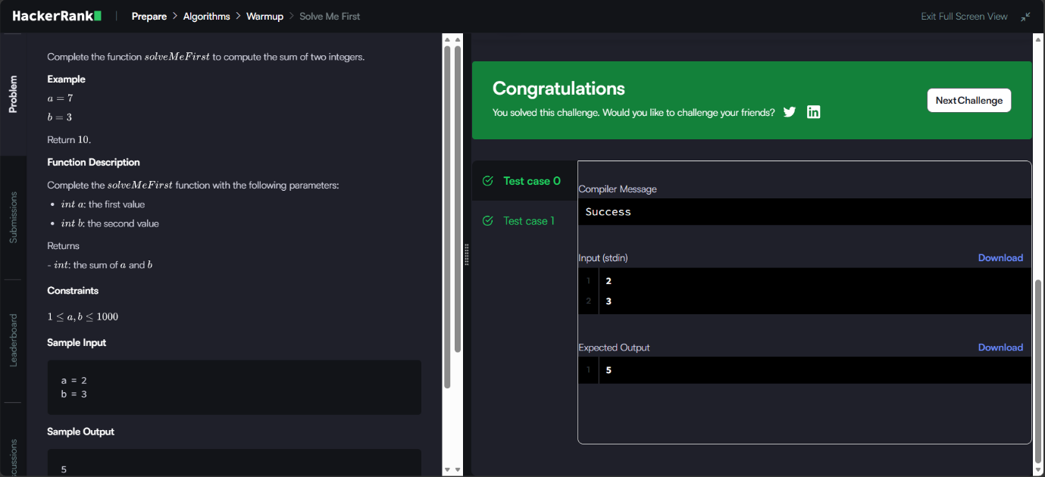
Source Code


